SATISH PRADHAN DNYANASADHANA COLLEGE, THANE
4.1.1 Infrastructure and Physical Facilities for Teaching-Learning
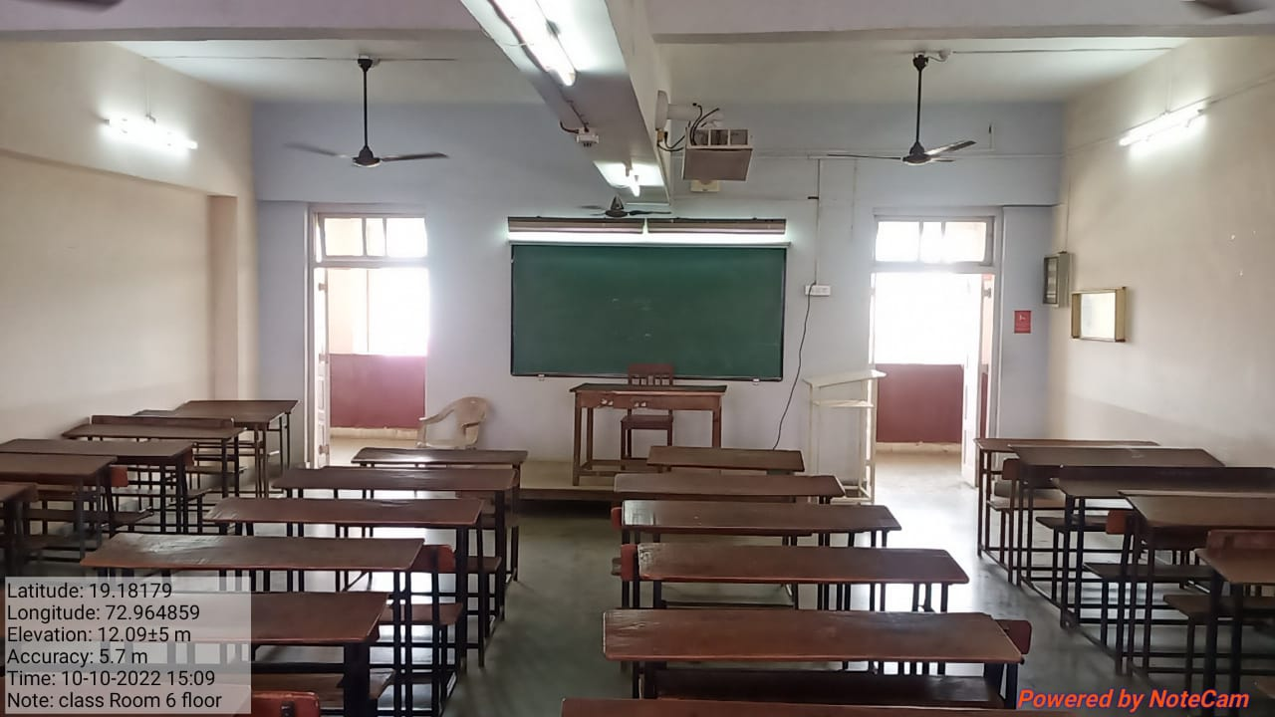
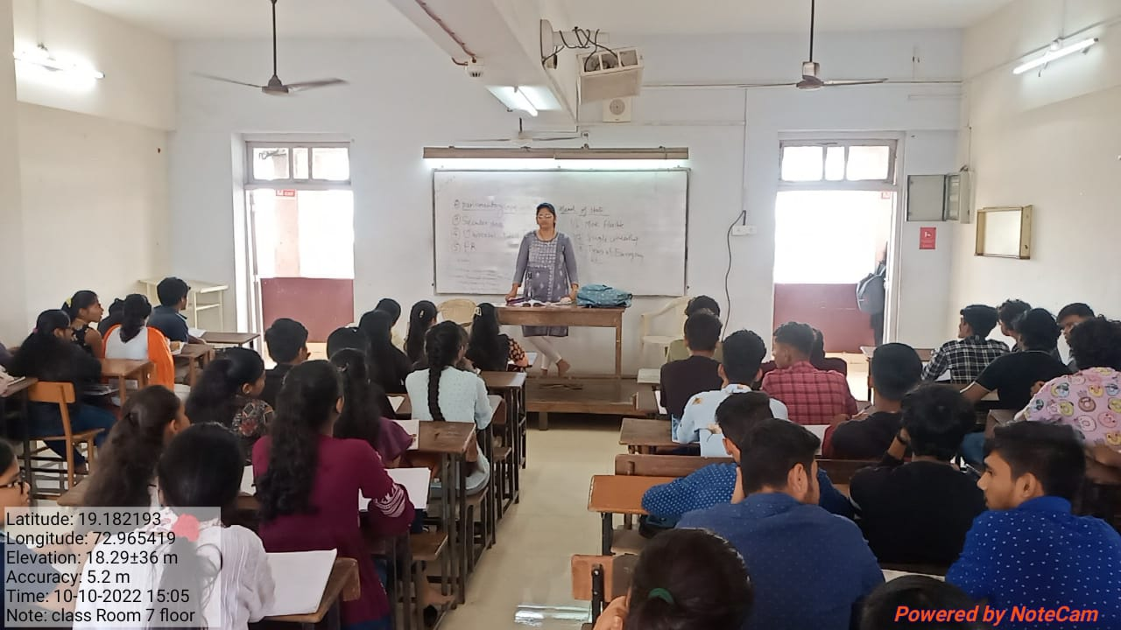

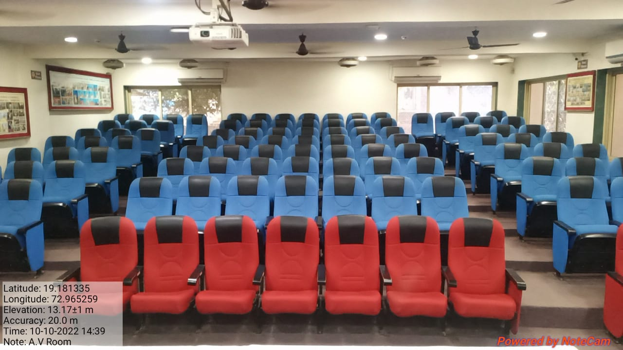
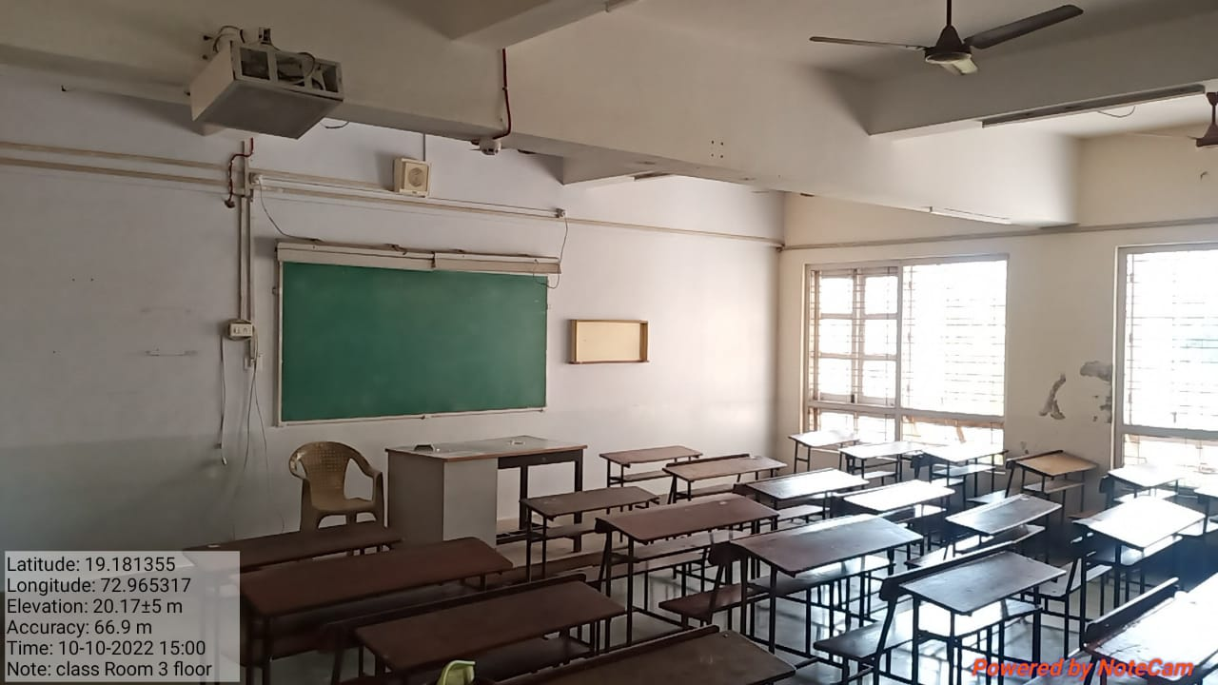

A. V. ROOM

SATISH PRADHAN DNYANASADHANA COLLEGE, THANE
4.1.2 Facilities for Cultural Activities, Sports, Games (Indoor, Outdoor), Gymnasium, Yoga Centre
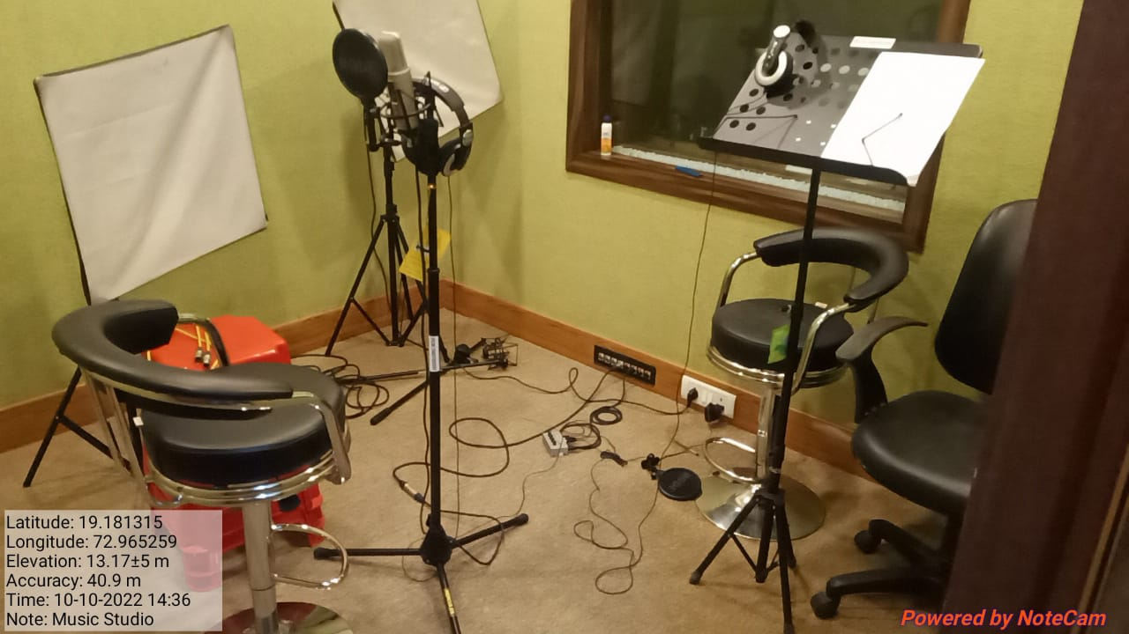
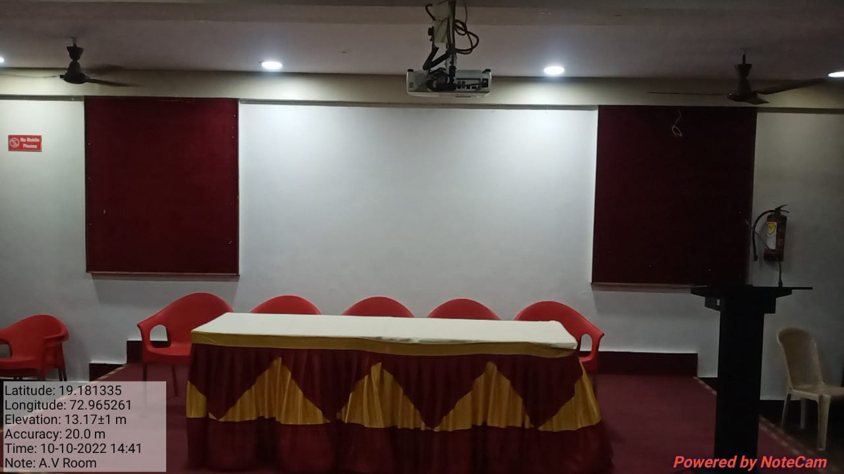
A. V. ROOM STUDIO

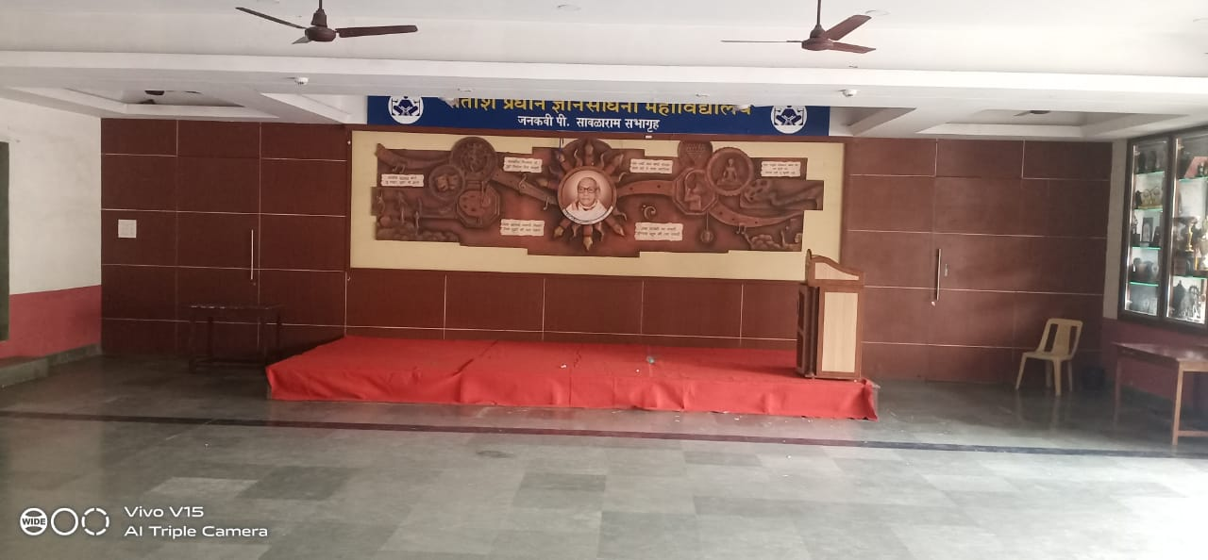
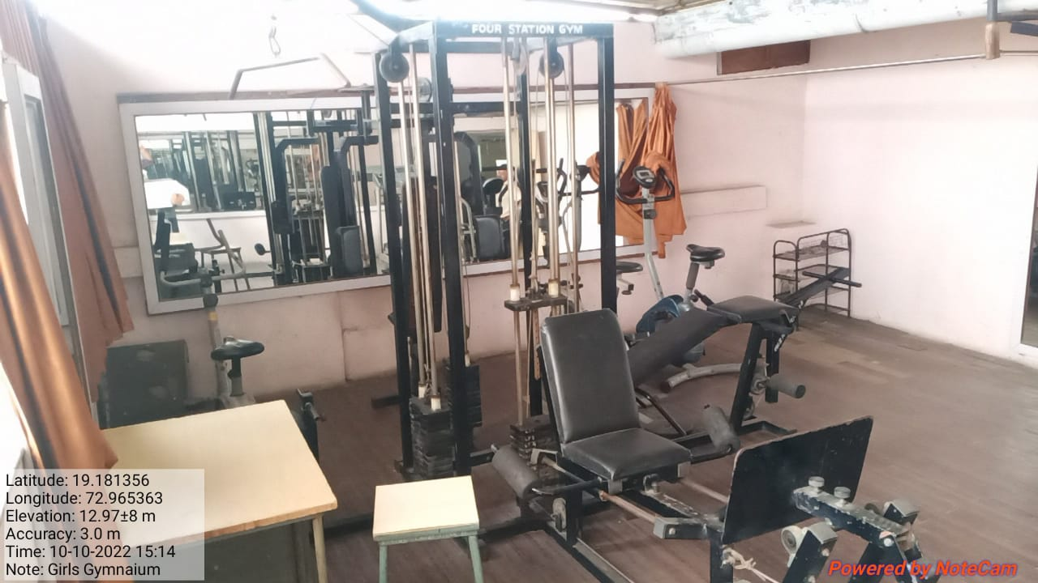

P. SAWALRAM GYMKHAN

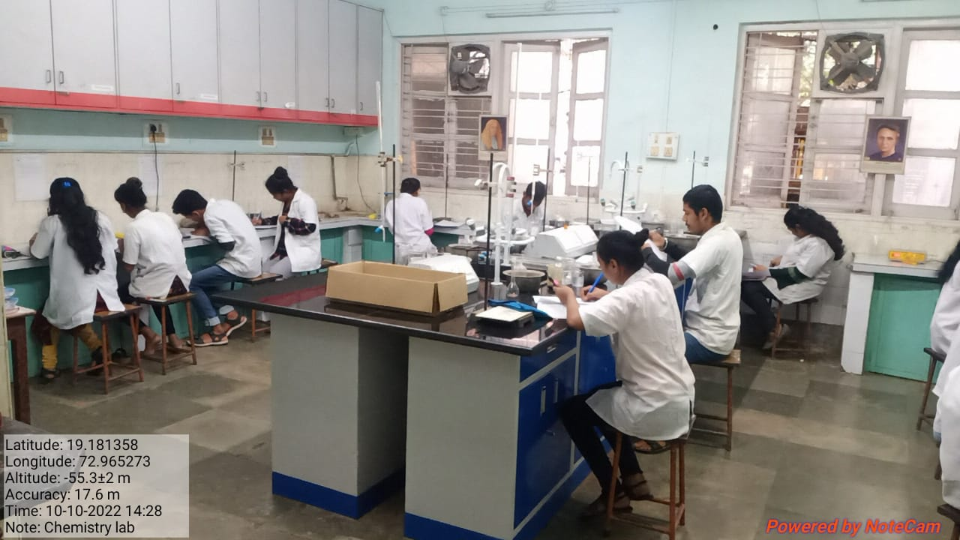
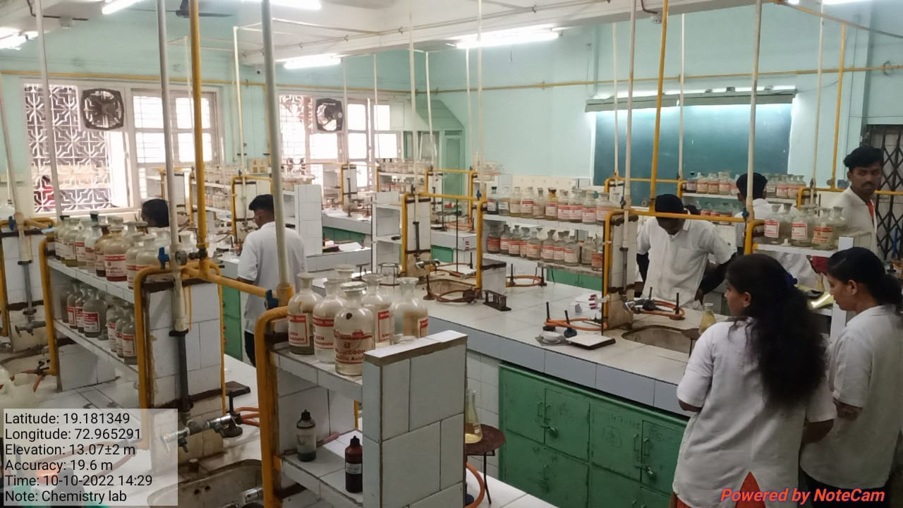

Chemistry Laboratory

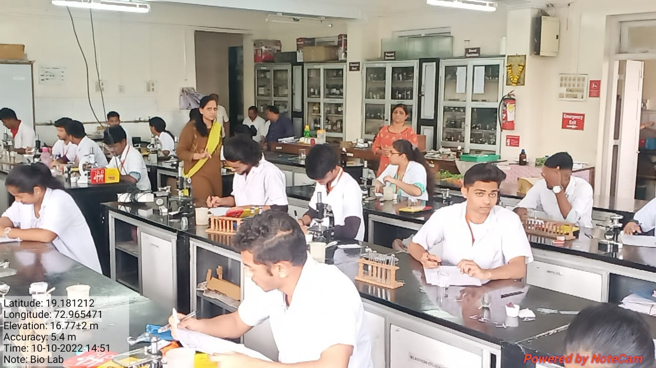
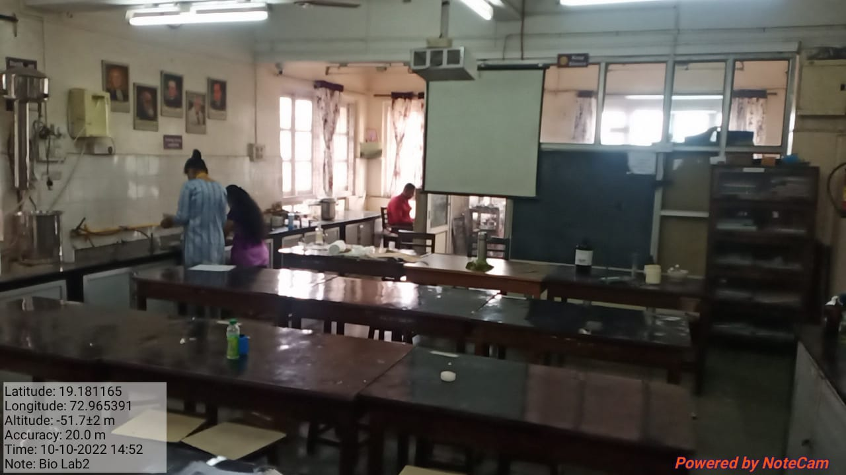

Botany Laboratory

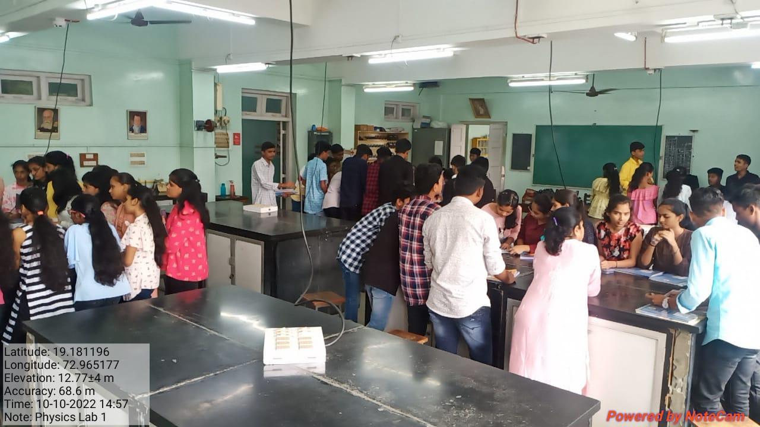
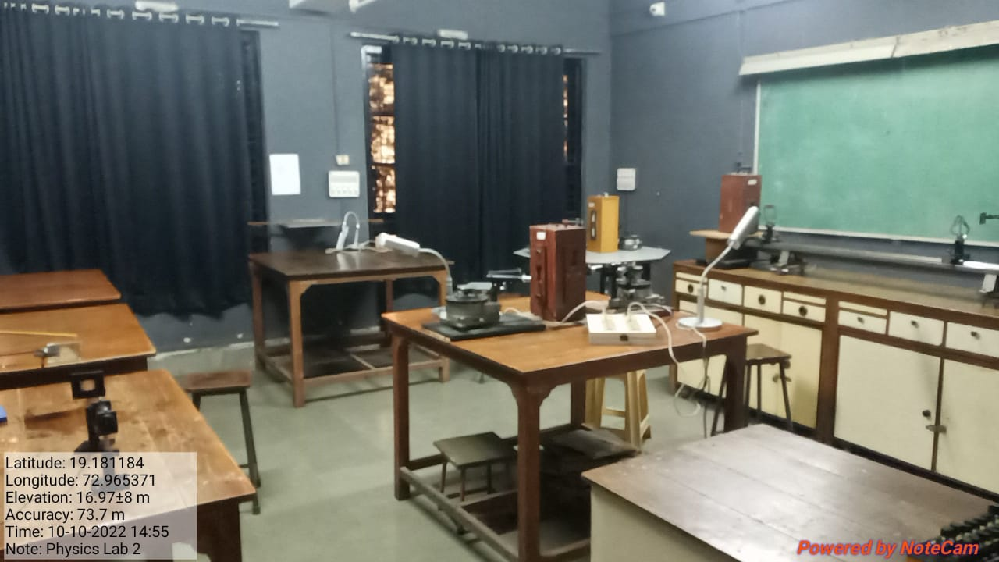

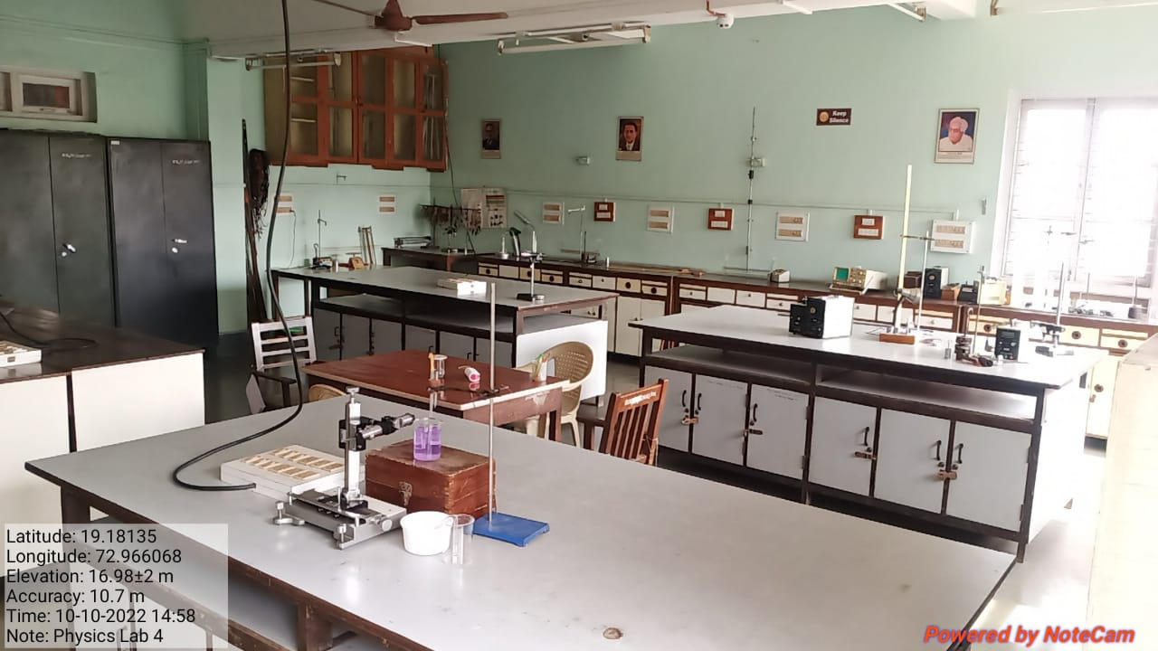

Physics Laboratory

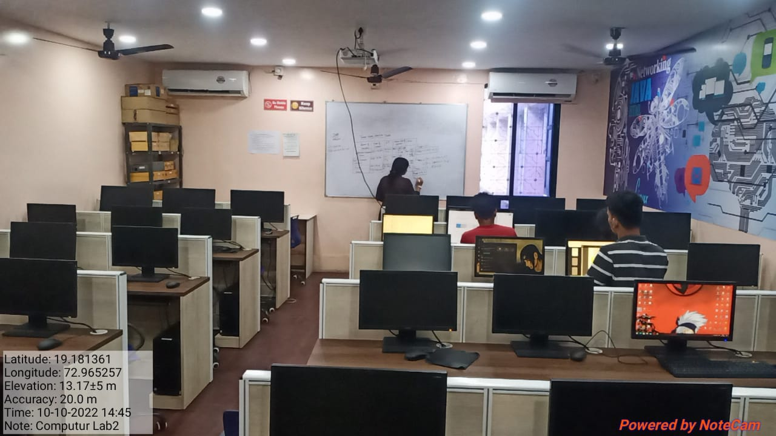
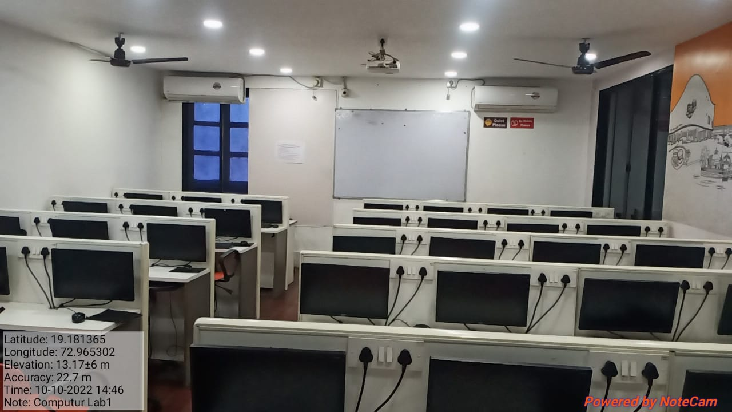
Computer Laboratory ICT Enabled Lecture Hall

SATISH PRADHAN DNYANASADHANA COLLEGE, THANE

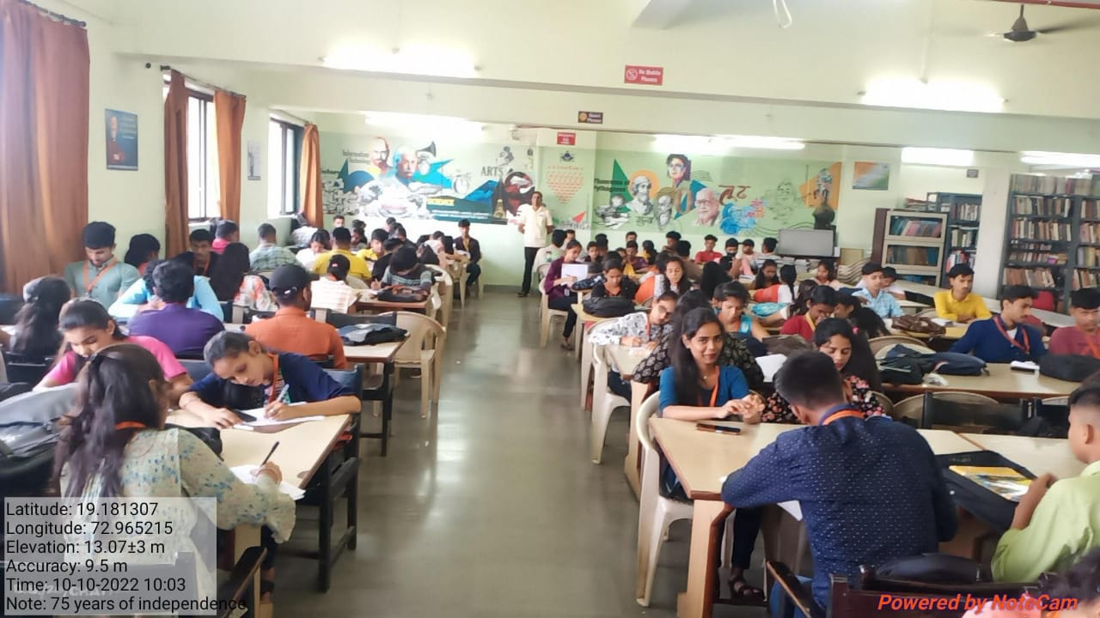
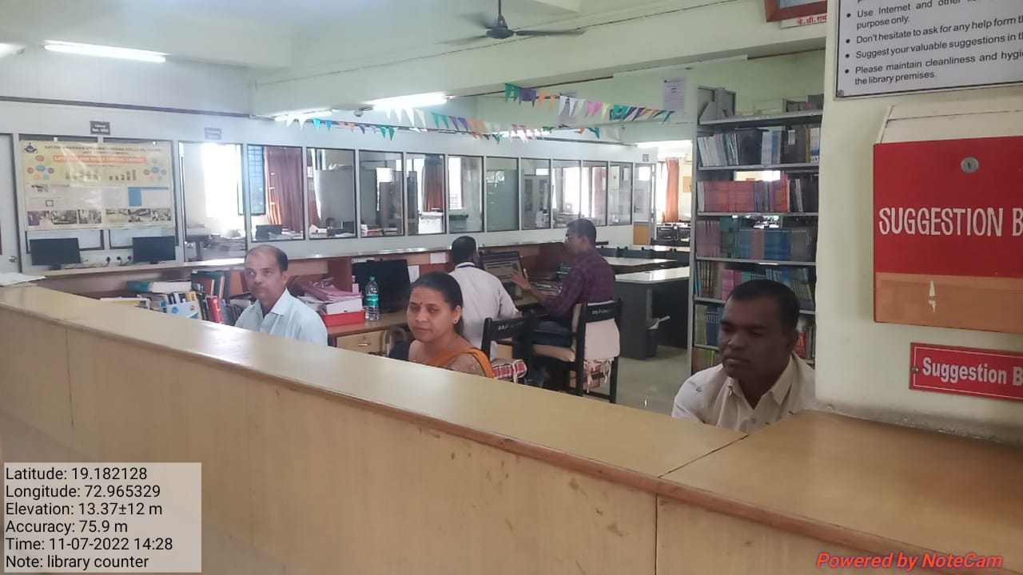

Library Reading Room Automated Circulation with use of
Barcode Technology
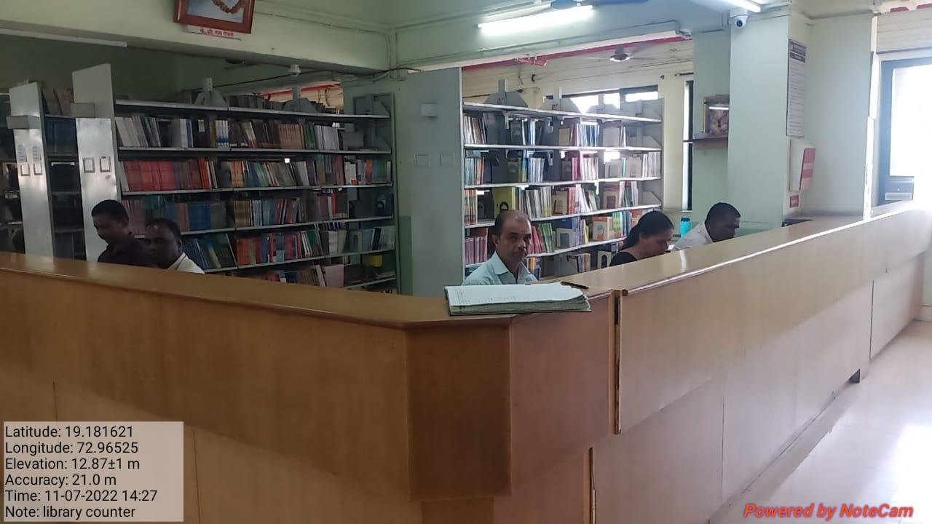

Library Circulation

